EXPERIMENT 22: Demonstrate Storage as a Service (SaaS) create and configure a new VM Image in any Public Cloud Service Provider.

Step 1: Create a Virtual Machine

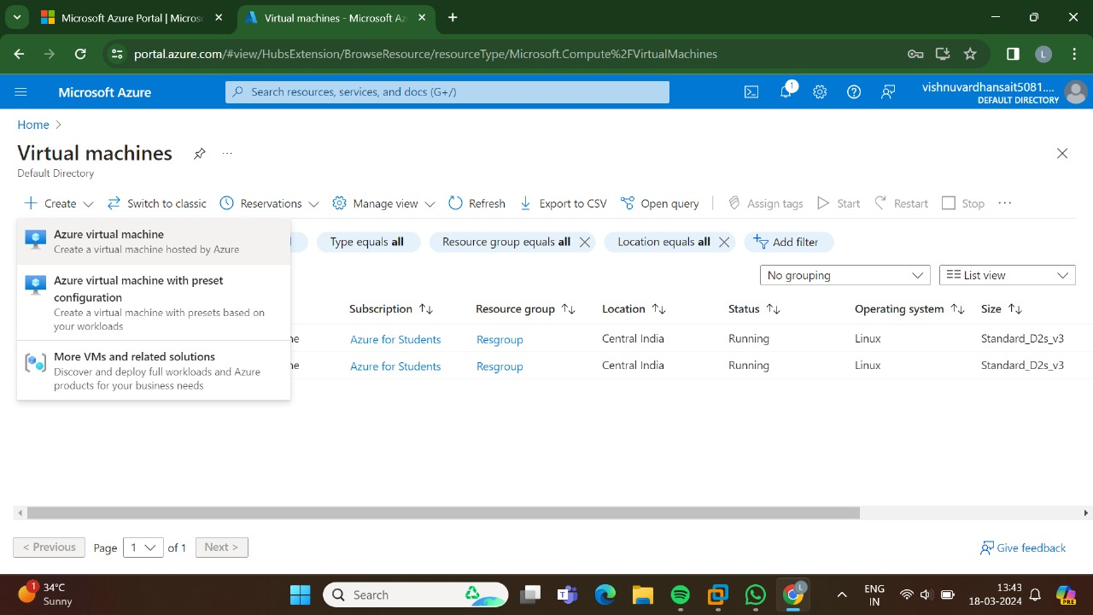

Step 2: Enter the Resource Group Details.

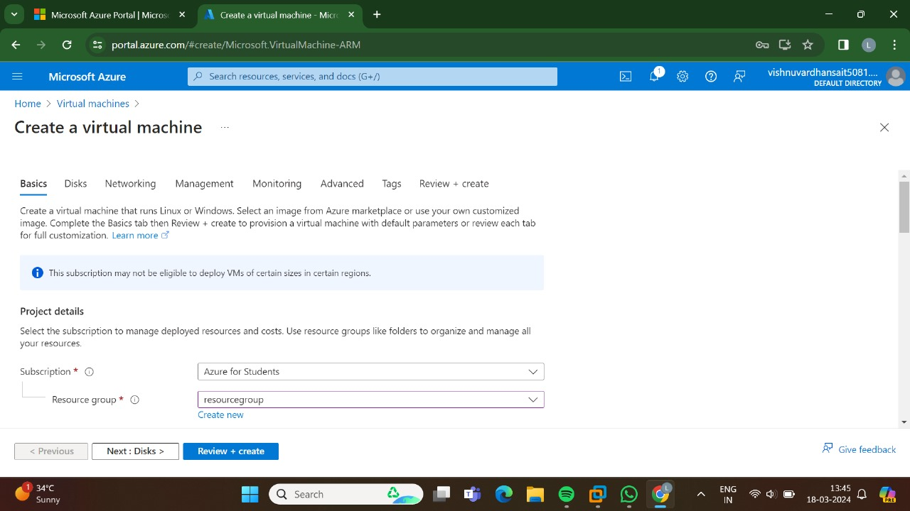

Step 3: Enter the Data Disk For Virtual Machine Details.

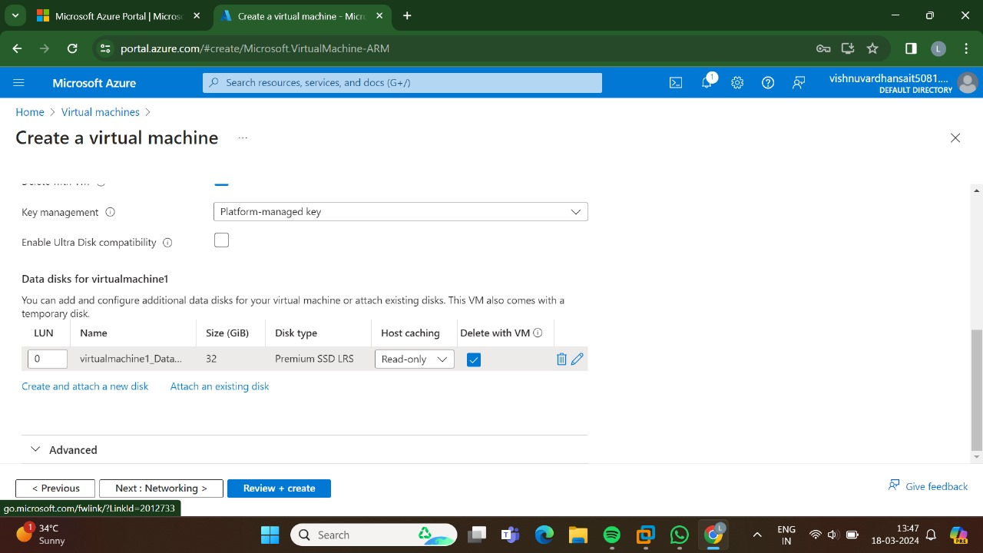

Step 4: Goto networking and Enter.

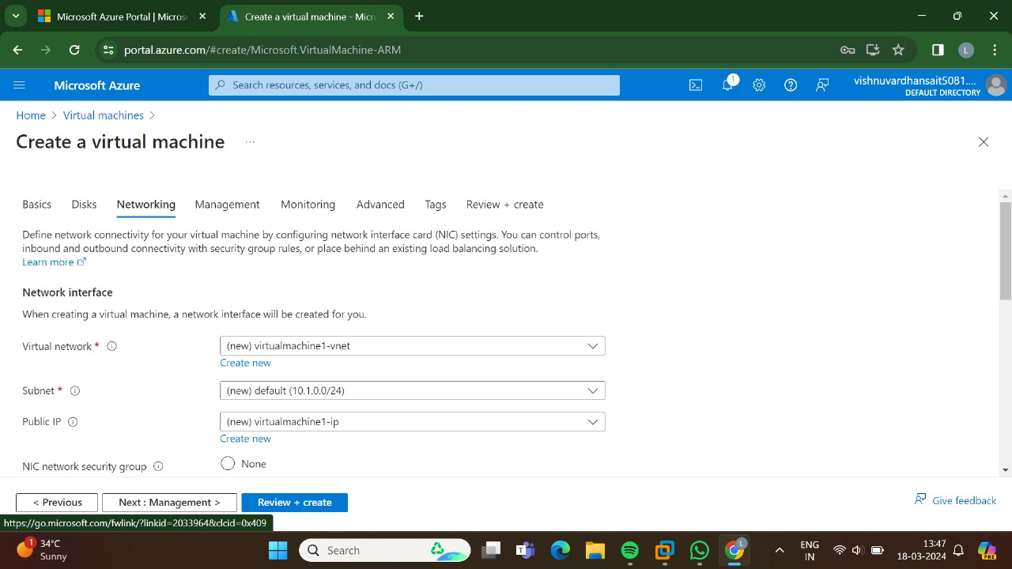

Step 5: Goto Management and enter details.

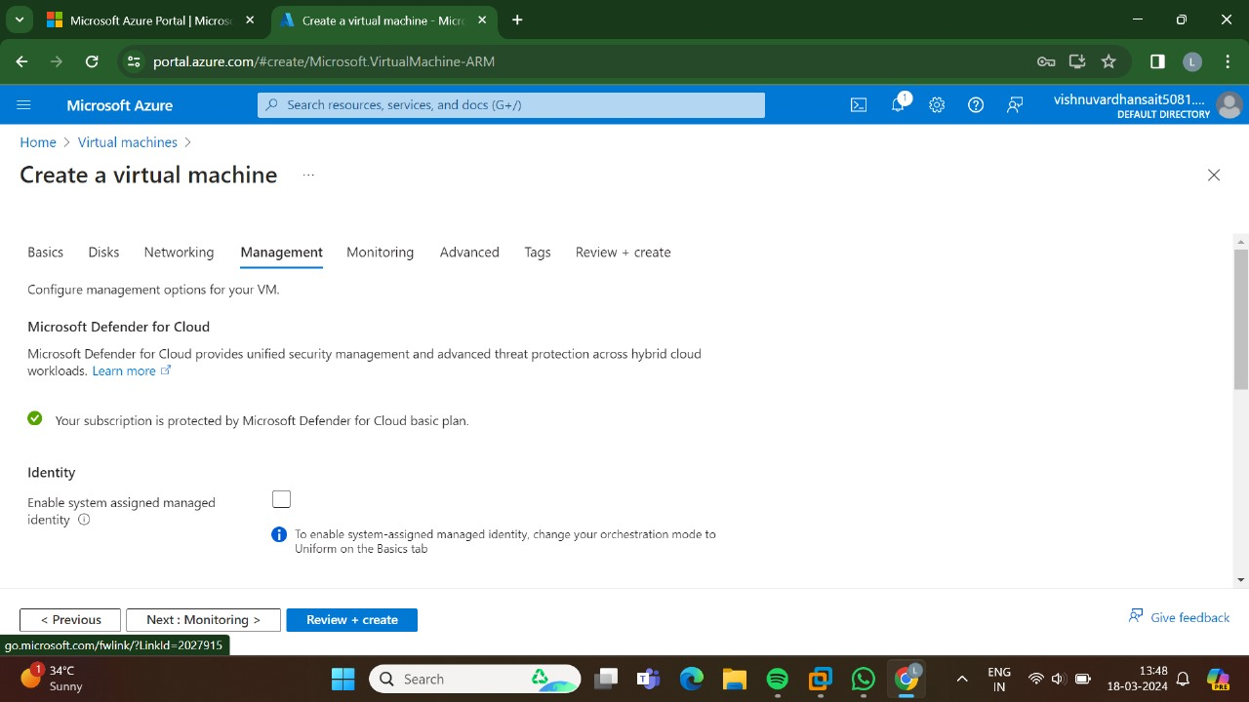

Step 6: Goto Monitoring and enter the Details.

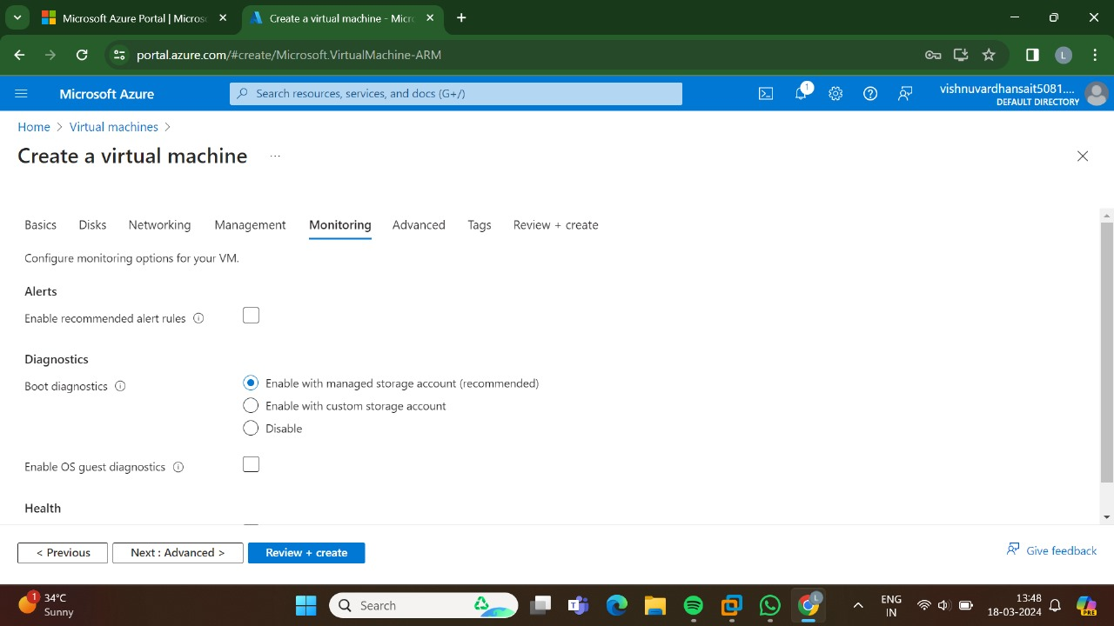

Step 7: Enter the Details.

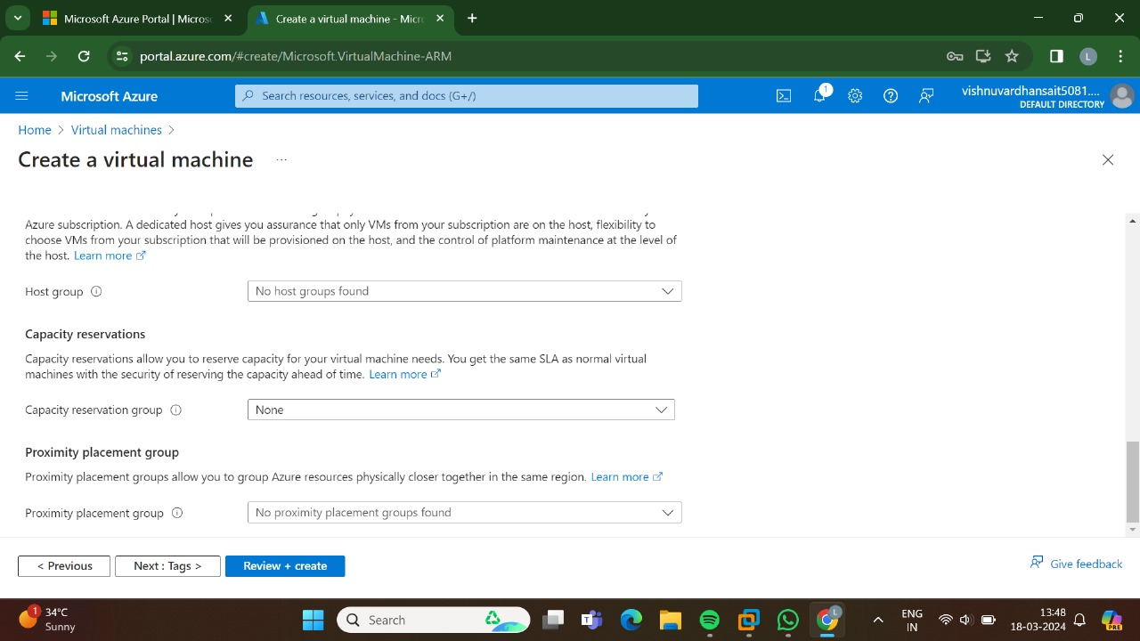

Step 8: Enter the Tags details.

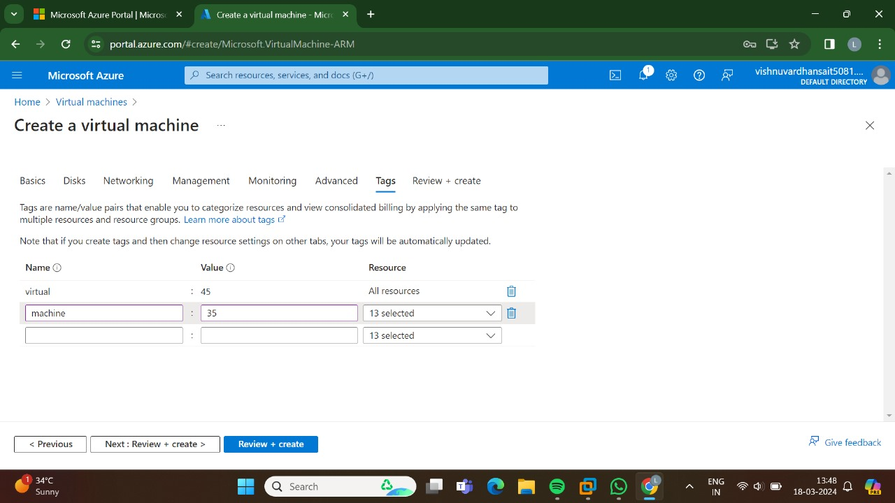

Step 9: Enter the create option.

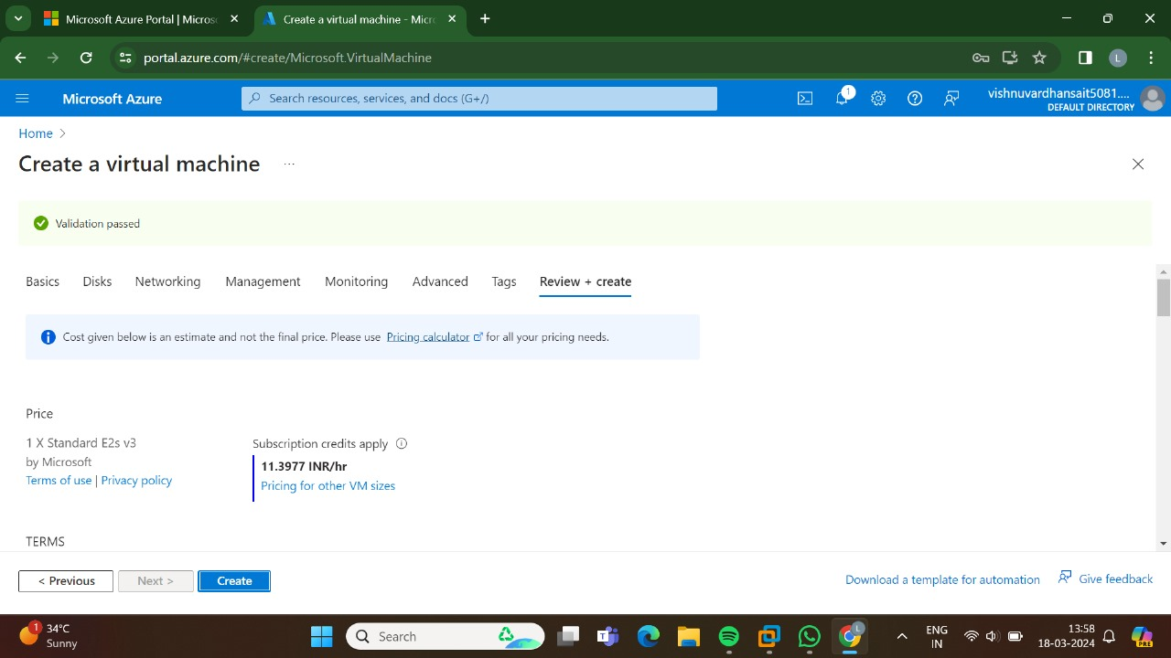

Step 10: Here Deployment is in Progress.

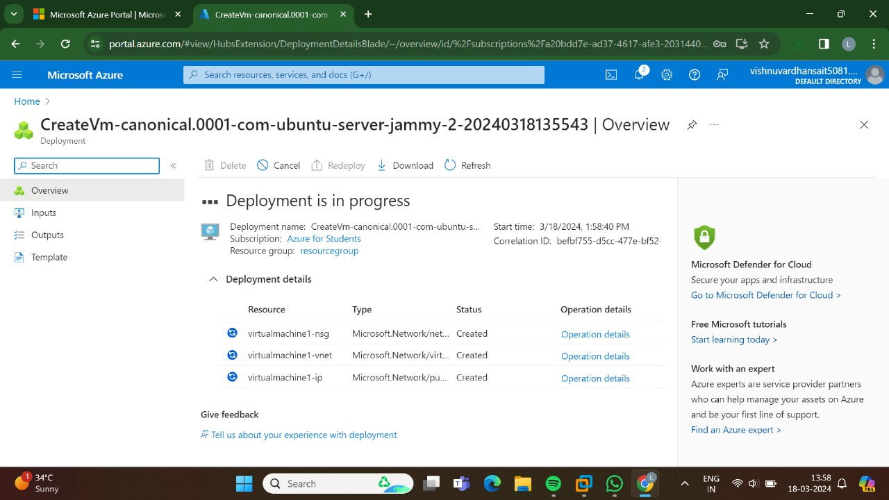

Step 11: Here we can get Ypur

